*Toro*

toro.tccd.edu

Griffin Gowdey

Spring 2021

Project Proposal

ITSE 1450

2/12/2021

I propose creating an informational website for an amateur/college baseball team. In this case, we will use the fictional Tarrant County College (TCC) Baseball team. This website will include all the features and information necessary for everyone on the team to do their job as efficiently as possible and to the best of their ability. I will be using TCC Baseball as an example, but this project could hypothetically be used for any baseball team or organization. I hope to present this to a TCC administrator even though they do not have an inter-institutional athletics department. I have yet to find the proper TCC representative, but I wanted to submit this prior to the 02/12/2021 at 11:59 PM to make sure that everything else was in order. There is also the possibility of presenting this or tailoring this website to one of the local Dallas-Fort Worth area university baseball teams such as Texas Christian University (TCU) or Dallas Baptist University (DBU) who are both analytically inclined programs. TCU Baseball staff contact information can be found at (gofrogs.com/sports/baseball/coaches) and DBU Baseball staff contact information can be found at (dbupatriots.com/sports/baseball/roster) near the bottom. If I cannot find a TCC representative to present this to, then I will reach out to one of the local baseball programs.

Technology use and data collection has been increasing rapidly in baseball. It is now more important than ever that teams have all their information in one easy to access place and in a clear or easily digestible format. Amateur (all levels below professional/MLB/MiLB) baseball teams currently use many different applications or websites to conduct their operations. These areas operations include, but are not limited to recruiting, communication between team members and coaches, strength and conditioning, video collection and dissemination, data collection and dissemination, and scouting. Each area usually involves the use of one or more applications or websites. For example, the data collection and dissemination category is usually made up of TrackMan (trackmanbaseball.com), BATS (sydexsports.com/bats), Blast Motion (blastmotion.com), Diamond Kinetics (diamondkinetics.com), and Motus (motusglobal.com) among many possible others. The applications, websites, and informational streams start to pile up and it becomes increasingly difficult to manage everything. This usually involves hiring more people and buying more devices to manage everything, which leads to an increase in spending. This creates a disadvantage for teams on a budget as software developers are usually expensive and student/graduate assistants can only go so far.

While this website would primarily serve the respective baseball program’s work needs, it would also include an API for any interested parties. Specifically, it would be for MLB organizations. I spent 2020 working as a Support Coordinator in the Baseball Systems department for the Texas Rangers. The Baseball Systems group was responsible for maintaining and building the Texas Rangers’ proprietary information website named *Bunker* (scout.texasrangers.com), which is used by the Baseball Operations department to conduct their daily business. With this position, I was able to see the flow of amateur baseball player information and where the current methods are deficient. I also worked for the Houston Astros in 2018 as a Minor League Technology Apprentice and became very familiar with their internal Baseball Operations website named *Ground Control* (groundcontrol.astros.com). I realized after working for both organizations that amateur scouts had to manually input all their player information, which is a very burdensome task considering the number of players they see and write reports about. It would also provide scouts with the opportunity to see all necessary video and information about an interested player. Essentially, it would automate the informational process for amateur scouting departments.

Take this excerpt from an article (espn.com/mlb/story/_/id/13106874/why-houston-astros-database-worth-hacking) about the Astros’ *Ground Control* website.

“To illustrate just how wide-ranging the available information is, and how it all works in practice, Luhnow described to Bloomberg last year a made-up example of a college prospect the Astros might be considering.

"Let's say he's played two summers in a wood-bat league," Luhnow began. "He's got hundreds of Division I at-bats with a composite bat but against a wide variety of competition. You've got scouts' input on his potential. Your video analyst says his swing is in the top quartile of swings he's seen that lead to success in the major leagues. Your area scout says his character is in the top 10 percent of players. But he's a C-minus student. Not academic, doesn't learn well. Your doctor says he's got a slightly above-average risk of sustaining an injury.

"I've just given you nine pieces of information. How do you weight them?

"I can't do that in my mind. It's overload for any human being."

Even saying "top quartile of swings" three times fast is hard.

The info gathering doesn't stop there. Anyone hacking into a database like Ground Control could also find the detailed physical, psychological and statistical profiles compiled for the amateur draft, notations on trade talks and analytics-based wish lists on whom to pluck off the waiver wire or promote from the minors.”

All this information is manually entered by an MLB team amateur scout into their own team’s informational system, which is extremely time consuming especially if they cover a large region of players. This website would expedite that process. A scout or team representative would have their own personalized login to the website or have their team use the API to integrate with their software and have everything they need to evaluate the player to the best of their ability. Overall, this site would be for baseball teams like what Canvas or Blackboard is to educational institutions.

I will be working alone on this project, but I will more than likely reach out to my contacts or other software developers for some guidance. I will be using HTML and CSS for the front-end design and C++ and/or Python for the backend. I feel more comfortable with C++ than Python, but I will more than likely end up using both. A database will also have to be set up for the website if any of the respective TCC Baseball staff members want to run advanced SQL queries. The front page would include 6 options or boxes to click/choose from that include Public Access, Private Login, Request Private Login, Staff Login, Recruitment Login, and API Documentation. Below is a photo of my first draft coding the front page.

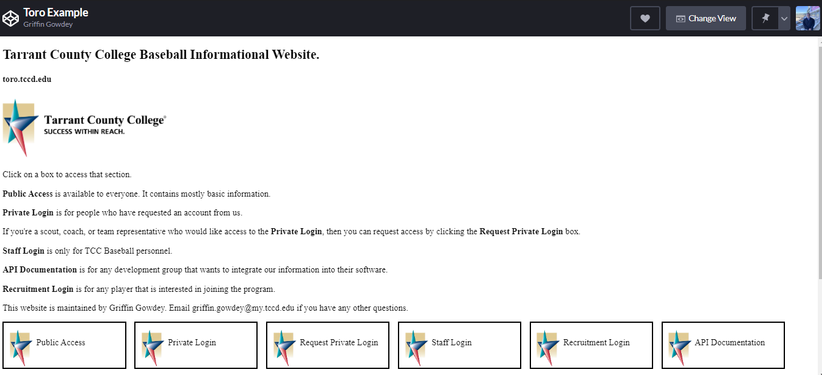

*Public Access* would be available to anyone that visits the site. It would contain mostly basic information that you would typically see on any university baseball page with limited advanced metrics/information from the Private Login section. Regular speed play-by-play game video with multiple angles would also be included. An example is the TCU Baseball program page (gofrogs.com/sports/baseball).

*Staff Login* would be for all TCC Baseball personnel and would include areas such as, but not limited to game schedules, practice schedules, player development plans (strength and conditioning), player development tools, game/practice video upload, scouting reports, and educational material hosting. Some examples of player development tools that I would model this section from include (drivelinebaseball.com/coaches/traq), (edgefree.drivelinebaseball.com/free_tools/visualization), and (baseballcloud.com/ballR). These tools would also integrate with my website if they had their own respective API. If not, it would contain the login information for each TCC Baseball staff member to access it. Below is a photo of an example draft coding this page.

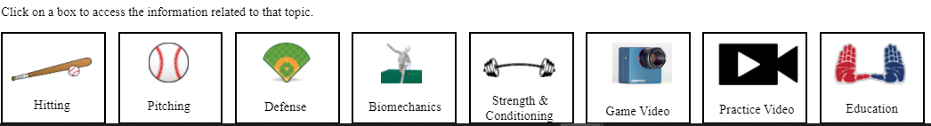

*Private Login* would be for high priority third parties such as college scouts/teams, professional baseball scouts/teams, and third-party scouting organizations. Each person within that organization would have their own individual login. This section would contain player profiles with advanced metrics and video highlights. This section would also include full play-by-play game/practice video with multiple angles from both regular speed and high-speed cameras. A player profile example is (prepbaseballreport.com/profiles/GA/Brady-House-6514832079-2357689401). A play-by-play game video example is (sydexsports.com/bats). An advanced metrics view example is (baseballsavant.mlb.com).

*Request Private Login* would be for any individual that would like access to the *Private Login* page. This could anyone from a new employee to an MLB team to a 4-year university baseball coach that would like to recruit some TCC players. Requests would be approved or denied by the team administrator. The team administrator would also create the username and password. Once the username and password are sent back to the user, then the user will be required to change their password prior to their first login. The concept behind this is to limit who can view the advanced information and not let just anyone be able to access it.

*Recruitment Login* would be for any amateur player that is interested in joining the TCC Baseball program. This section would be based on the numerous job applicant tracking systems such as (workday.com/en-us/products/talent-management/talent-acquisition.html), (greenhouse.io), and (ultimatesoftware.com/UltiPro-Solution-Features). A potential recruit would pick their graduation year and fill out a questionnaire. This application would allow them to attach any documents or links for skill level showcasing. The main goal here is to have one place to track recruits by their graduation year and be able to send automated messages to notify them whether TCC Baseball is interested or not. Like the job application process, the TCC recruiting personnel would be able to accept or deny applicants. This helps prevent clutter and is more efficient than the typical “if interested in joining our program, then send email to….” method where the emails and replies can be overwhelming. This is especially true if one works for a popular baseball program.

*API Documentation* would be for any interested third parties who would like to integrate TCC Baseball information into their own platform. Some examples of MLB team Baseball Operations websites are (houstonchronicle.com/sports/astros/article/Astros-formula-for-success-builds-on-its-own-5300746.php), (mlb.nbcsports.com/2014/03/09/astros-using-private-online-database-called-ground-control), (dv.indiansfrontoffice.com), (scout.texasrangers.com), (beacon.redsox.com), and (ivy.chcubs.com).

In general, this website will benefit the organization by creating a single location for the TCC Baseball staff to complete all their work in an easy-to-use interface. It will also significantly trim down the information process from TCC Baseball to professional baseball organizations via automation. TCC Baseball would no longer need to hire multiple student/graduate assistants for data collection and analysis or hire more coaches to meet demanding workloads. Workflows would be automated, and information would be readily available for viewing.

The proposed system would reduce costs by not having to hire as many individuals, which could save upwards of multiple full-time salaries and benefit payments each year. The system will not increase revenue for the baseball program as the main goals of the program are to win games and produce better players, not necessarily to increase revenue. This system will very much result in more information in a clear and digestible format for all relevant parties. Information would be easy to access and the results would be measurable by the number of players being drafted into professional baseball and/or moving on to 4-year schools. Customers such as MLB team personnel and 4-year college baseball program recruiting coordinators would have easy access to information needed to do their job to the most efficient and effective standards.

This project can be implemented in a reasonable period. I plan to complete everything or at least have the main pages done by the end of the semester due date. I have a decent amount of it presently done, so at this point I just need to expand upon it. The project results will continue to last as baseball technology improves, which means that more features will be added or improved as time goes on. I have all the resources I need to complete this project. The goal is to have a functioning beta up by the end of the semester. This project needs to exist because there is a large need for it in the baseball world. Most amateur baseball organizations do not have the means to keep up with all the emerging technology and data sources in baseball, so it is important that someone creates a product that is easily deployable to the baseball community. More features and functionality such as live game streams, slow motion video capture, and marker less motion capture/mechanical analysis can be potentially added as time goes. Machine learning and computer vision will dominate baseball over the next decade, so there are numerous possibilities for enhancement.

I plan to interview my user(s) sometime near the due date of the entire assignment. If I end up finding a local baseball program to create this for, then I will have to work around their schedule since baseball season will be in full swing. I estimated that this will take me the entire semester to complete and anywhere from 10 to 20 hours per week. No cost is needed as I will be doing it on my own and not for any employer. The amount of time it took me to write this proposal was 8 hours.